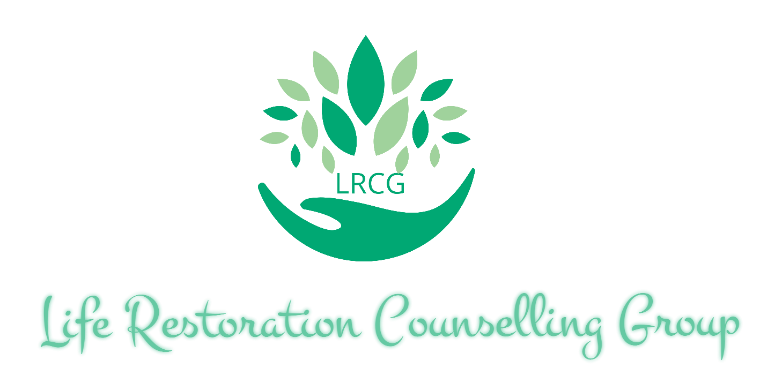

Client Welcome Package

Table of Contents

p.3 How Can We Help
p.4 The LRCG Therapeutic Model
p.5 “Getting To Know You”
p.6 Confidentiality Agreement
p.7 Electronic and Telecommunications Consent
p.8 Fees of Service
p.9 Insurance Coverage
p.10 Client Signature Page

How Can We Help

At LRCG we are striving to change the face of counselling and assist individuals, couples, and families in attaining their self-determined goals by rejuvenating and restoring themselves and their relationships. We help with a variety of issues and difficulties such as:
- Anxiety
- Depression
- Marital or relationship issues
- Parenting
- Addictions
- and other issues that may affect the quality of your life
At LRCG we respect that people who seek counselling have busy lives and reside in a technologically advanced environment. We currently offer:
- Telephone counselling
- video-calling sessions
- and face-to-face counselling sessions
The counsellors at LRCG have extensive experience in the community of social services and mental health which has created an awareness of the gaps in service for people seeking counselling today. In keeping with our mission to change the face of counselling, we will be expanding our team to attain our goal of creating the opportunity for people who utilize our service to be referred to other counsellors within LRCG. This interagency referral system will cut down wait times to see a specialized counsellor and allow for the LRCG counsellors to work together in providing the best service to you.
Our hope for you, is that we can provide a counselling experience that not only restores your life and relationships, but also enables you to have a positive impact within your community.

The LRCG Dynamic Therapeutic Model

- Counselling sessions (in office/video/telephone)
- At home activities and work to support the process of the therapy
- Involvement of a family member or kin at a session to create a comprehensive counselling experience
- A medical or psychiatric referral in order to rule out any other possible contributing factors

Getting To Know You
Full Name: Click or tap here to enter text.
Date of Birth: Click or tap to enter a date.
Address: Click or tap here to enter text.
Postal Code: Click or tap here to enter text.
Phone #: Click or tap here to enter text.
Can you receive confidential voicemail message on the number provided? YES☐ NO☐
Email: Click or tap here to enter text.
Please circle and answer the following questions.
- Have you attended counselling before? Yes☐ No ☐
  - If so, how would you rate your previous experience 1-10 (10 being very good) Choose an item.
- Did you seek out counselling support on your own, or were you encouraged to do so by family/friends/it was required?
Click or tap here to enter text.

- What are your top 3 fears or worries about seeing a counsellor?
      - Click or tap here to enter text.
      - Click or tap here to enter text.
      - Click or tap here to enter text.
- Name 3 areas of your life or difficulties that you currently face that you would like to address in counselling.
      - Click or tap here to enter text.
      - Click or tap here to enter text.
      - Click or tap here to enter text.

Confidentiality Agreement

‘‘Principle V, Confidentiality of the Code of Ethics and Standards of Practice is of relevance:
5.1 College members comply with any applicable privacy and other legislation.
College members obtain consent to the collection, use or disclosure of client
information including personal information, unless otherwise permitted or
required by law.
5.3.1 When College members are employed by an agency or organization,
College standards of confidentiality may conflict with the organization’s policies
and procedures concerning confidentiality. Where there is a conflict, College
standards take precedence.
5.3.6 College members do not disclose the identity of and/or information about a
person who has consulted or retained them unless the person consents. Disclosure
without consent is justified if the disclosure is required or allowed by law.‘‘
(OCSWSSW, Code of Ethics and Standards of Practice).

At LRCG we uphold the requirements set out by the Ontario College of Social Workers and Social Service Workers (as noted above). We will ensure complete confidentiality of our client’s information disclosed during our sessions and our records unless there are extenuating circumstances such as:
- You make a disclosure relating to harming yourself or another person,
- There are concerns relating to the safety and well-being of a child (see Section 72 of the Child and Family Services Act),
- It is required by a designated authority (i.e. Police Services).

Children over the age of 12 may consent to counselling and have their confidentiality respected except in the case of extenuating circumstances as stated above. Children under the age of 12 must have both parents sign a consent form prior to the commencement of counselling. Should one parent have sole custody, LRCG counsellors must have proof of the court order.

Clients may consent to LRCG counsellors speaking to family members, doctors, schools etc through signing a release of information. The consent form will be provided to you and will be kept on file.

Consent for Electronic and Telecommunications

Acknowledgement and Consent:
• Electronic communication may be utilized by LRCG counsellors or therapists in the course of their work with clients.
• Electronic communication and telecommunication, include but are not limited to: text messaging, video conferencing, and email platforms.
• Electronic communication will use respectful language.
• Electronic communication will not be used for frivolous or commercial purposes. Or any purpose outside the context of direct client-counsellor relationship.
• Electronic communication will become part of confidential client records.
• Electronic communication is easier to falsify than handwritten or signed hard copies. In addition, it is impossible to verify the identity of the sender, or to ensure that only the recipient can read the electronic communication once it has been sent.
• Electronic communication can introduce viruses into a computer system and potentially damage or disrupt the computer.
• Electronic communication can be forwarded, intercepted, circulated, stored, or even changed without the knowledge or permission of the counsellor or client. Electronic communication senders can easily misaddress an email, resulting in it being sent to many unintended and unknown recipients. Electronic communication is indelible. Even after the sender and recipient have deleted their copies of the email, backup copies may exist on a computer or cyberspace.
• Use of electronic communication to discuss sensitive information can increase the risk of such information being disclosed to third parties.
• Emails may be forwarded internally to those involved, as necessary, for administrative purposes or accounting requirements.
• LRCG is not responsible for information loss due to technical failures.
• I will notify LRCG of any changes to my electronic communication address or contact information.
• I am herein not holding LRCG liable and/or responsible should any private and confidential information be subject to hacking or otherwise loss of private information via the aforementioned platforms.

By your signature on Page 10, you are indicating that you read and understood this consent form and that any questions you had about this consent form were answered to your satisfaction.

Fees of Service

Please reference each counsellor/therapist for their individual rates.

- Individual Session Fees range from $105-$150 for 50 to 60 minutes

- Couples Session Fees range from $125 - $180 for 50 to 60 minutes

- Family Session Fees range from $150 and upward depending on the amounts of participants and length of time.

Important notes:
- All payments are required to be made prior to the commencement of the session.
- Tentatively booked sessions are held for 24-48 hours after being offered
- Social Work services are HST exempt
- Home visits have a $20 fee (available within 10 km of the office).
- Any other services in excess of 15 minutes (i.e. report writing or contact with other professionals) will be billed at the usual hourly rate and will be discussed with you in advance.
- Rates are subject to increase each year. Active clients will be notified via email of increased rates with a minimum of 60-day notice. Please speak to your counsellor regarding financial constraints.
- LRCG counsellors require 24 hours notice of a cancelled appointment. Should sufficient notice not be provided, the full scheduled appointment fee will be charged
- Sessions are considered missed after being late by 20 minutes. Missed sessions are considered cancelled without notice.
- Late payment can be subject to a late fee of $25

Insurance Coverage and Payment
FORMS OF PAYMENT:
LRCG counsellors are accepted by most extended health benefits insurance providers. Payment by the client is received first and you are then reimbursed by your insurance provider. We accept cash, electronic money orders (required prior to the beginning of the session), VISA, Mastercard, American Express and Discover via point-of-sale readers.
Please contact your insurance provider to verify coverage prior to our first session.
You can ask some of the following questions when contacting your insurance provider:
- Do I have coverage for a registered Social Worker for counselling services?
- How many sessions per year does my health insurance cover?
- What is the coverage amount per therapy session?
- What is the amount of my annual coverage?
- What is my deductible for each session? ​
- Is approval required from my primary care physician?
Social Work services are not covered by OHIP, however are considered a medical expense tax credit for income tax purposes. Any fees not covered by your benefits plan can be claimed when you file your income tax return.

Client Acknowledgement and Signature

I hereby certify that I have read this disclosure agreement as well as all documents provided. I understand the contents of these documents and agree to the terms set forth therein.

If under 18 years, signed by both client and parent/guardian.

Client signature: Click or tap here to enter text.

Parent/Guardian signature (if required) Click or tap here to enter text.

Date: Click or tap to enter a date.

